***Mawlana Bhashani Science and Technology University***



**Department of Information and Communication Technology**

|  |  |  |
| --- | --- | --- |
| **Course Code** | **:** | ***ICT-3210*** |
| **Course Name** | **:** | ***Software Engineering Lab*** |
| **Name of the Lab** | **:** | ***Use Case Diagram of the project*** |
| **Lab No.** | **:** | ***02*** |

**Submitted by:**

**Md. Nazmul Hasan**

**ID: IT-17005**

**Session: 2016-17**

**3rd Year 2nd Semester**

**Submitted to:**

**Mr. Tanvir Rahman**

**Lecturer**

**Dept. of ICT, MBSTU**

**Santosh, Tangail-1902**

**Date of Submission**: 31-October-2020

**Use case diagram:** Only static behavior is not sufficient to model a system rather dynamic behavior is more important than static behavior. In UML, there are five diagrams available to model the dynamic nature and use case diagram is one of them. Now as we have to discuss that the use case diagram is dynamic in nature, there should be some internal or external factors for making the interaction.

These internal and external agents are known as actors. Use case diagrams consists of actors, use cases and their relationships. The diagram is used to model the system/subsystem of an application. A single use case diagram captures a particular functionality of a system.

Hence to model the entire system, a number of use case diagrams are used**.**

**Purpose of Use Case Diagrams:** In brief, the purposes of use case diagrams can be said to be as follows −

* Used to gather the requirements of a system.
* Used to get an outside view of a system.
* Identify the external and internal factors influencing the system.
* Show the interaction among the requirements are actors.

**The Use Case diagram of “Online Credit Fee Payment System”**

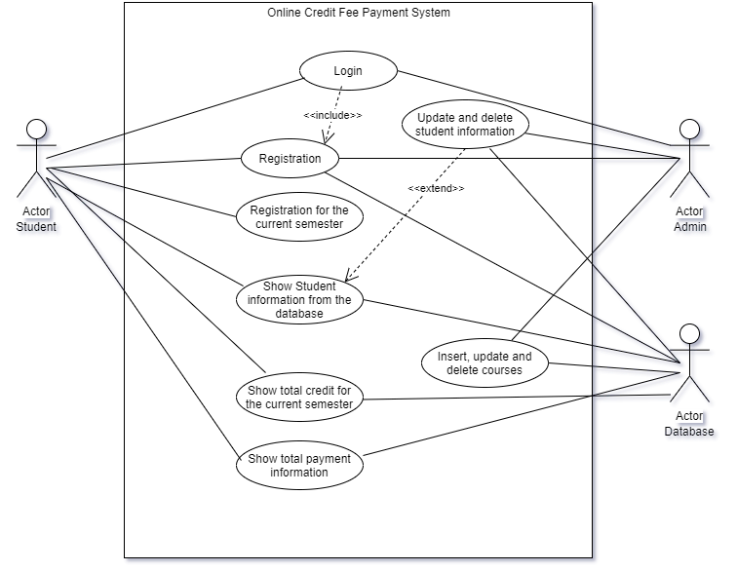

**Fig.** Use case diagram.

**Conclusion:** From this lab I come to learn about use case diagram. Our course teacher teaches us about use case diagram in class and told us to draw the diagram in online diagram editor.